DRAFT GRADE RAISE ANALYSIS REPORT | Project No. PCN  XX-0-000(000)000 (if available) 12345  From point A to point B  XX  Prepared by  NORTH DAKOTA DEPARTMENT OF TRANSPORTATION  BISMARCK, NORTH DAKOTA  http://www.dot.nd.gov/  DIRECTOR  Ronald J. Henke, P.E.  PROJECT DEVELOPMENT DIRECTOR  Jon Ketterling, P.E.  Principal Author: (Consulting Firm OR name, NDDOT Division name)  MONTH, YEAR
23 USC § 407
NDDOT Reserves All Objections

PROJECT NAME

PROJECT LOCATION

CERTIFICATION

Contents
1 Overview 1
2 Grade Raise Analysis 2
3 Recommendation 3

Overview

[Discuss the location of the crossing and basin in regards to the Highway, Reference Point, County, distance to the nearest town or junction, etc.]

[Discuss the field survey. Date completed, information recorded, e.g., roadway centerline and edgeline elevations, water surface elevations (WSE), critical overflow/outlet elevations, any culverts located in the vicinity of the grade raise.]

Location | Drainage Basin Crossing | Roadway Edgeline Elevation | WSE | WSE to Edgeline Elevation Difference | Outlet Elevation | Notes (recent flood events, terrain considerations, past grade raises, etc.)
ND Hwy ## (RP ##.#) | Name Lake | 1234.56’ | 1232.56’ | 2.0 ft | 1249.56’
ND Hwy ## (RP ##.#) | Slough (unnamed) | 1234.56’ | 1233.59 | 1.0 ft | 1239.56’

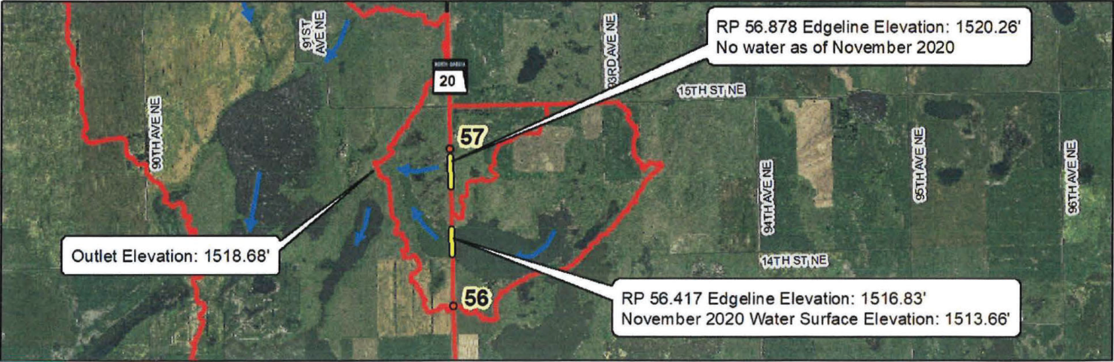

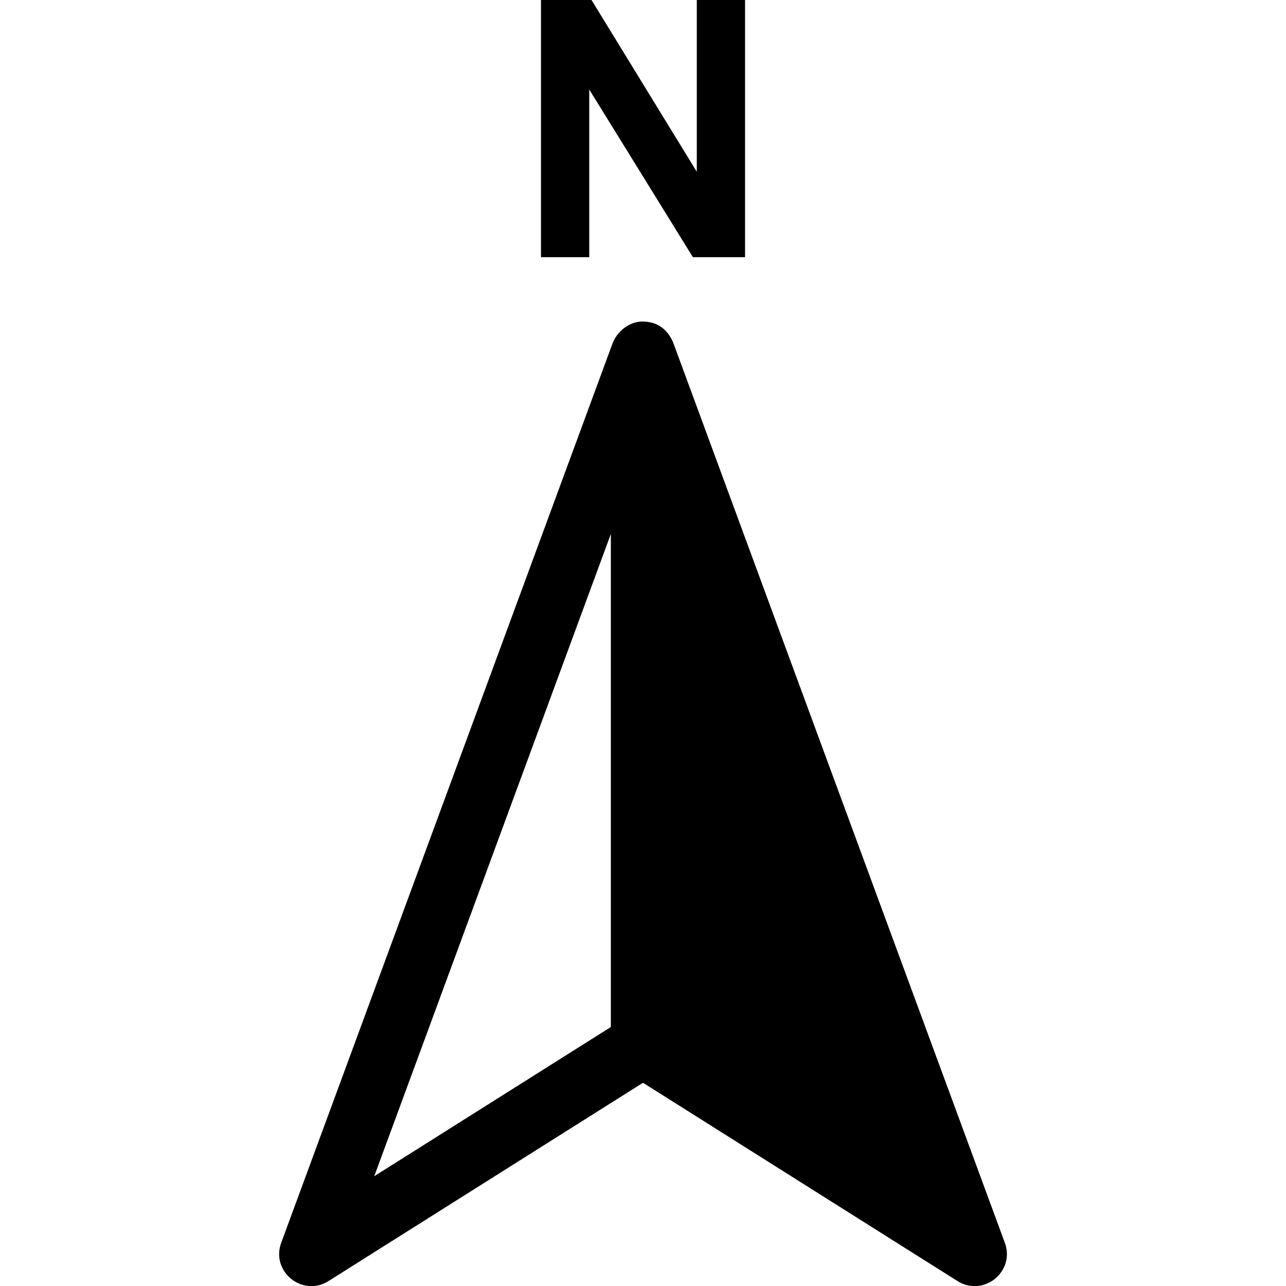

Figure 1: Project Location Map

[Discuss datum of elevations, source of elevations other than the field survey, e.g., LiDAR, and from where it was derived.]

Grade Raise Analysis

[Describe the drainage basin size and features; the primary direction of the drainage flow; the number and location of the culverts; any unique conditions in the function of the watersheds; the proximity of the WSE to the roadway features; the events that will proceed overflow conditions; etc.]

[Describe the modeling scenarios and design criteria used in the analysis]

 | Current Condition  (YYYY WSE) |  | Potential Future Condition  (Overflow WSE)
RP | ##.### | ##.### | ##.### + ##.###
Tailwater Elevation | ####.##' | ####.##' | ####.##'
Drainage Area (East / West) | ### / ### acres | ### / ### acres | ### / ### acres
Culvert Analysis | Independent | Independent | Combined
Hydraulic Calculations | Closed Basin Equalization | Directional Conveyance | Closed Basin Equalization
Culvert Recommendation | ø" RCP | ø" RCP | ø" RCP @ RP ##.###  ø" RCP @ RP ##.###
Table 1: Analysis Summary

Recommendation

[Choose one per crossing:
After consultation with NDDOT it was determined that due to circumstances (e.g., increased risk of flooding to structures within watershed) no grade raise is to be performed at this location.
According to the NDDOT policy for grade raise projects, if the outlet elevation is less than 15’ above the roadway, then a grade raise to the outlet elevation ####.##’ plus 2 feet of freeboard shall be analyzed.
According to the NDDOT policy for grade raise projects, if the outlet elevation is more than 15’ above the roadway, a 5’ grade raise will be constructed.
AND discuss the specifics of each crossing (e.g., wse, outlet elevation, subgrade elevation, etc.) that necessitate method utilized.] Assuming 15” for aggregate base and 4.5” for pavement surfacing, the edge of pavement elevation would be approximately ####.##’, which would result in the roadway being raised approximately #.##’.

[Discuss the culverts analyzed (e.g., number and centerline/approach), method of analysis (e.g., equalizer or directional), and standards adhered to.] All culvert information should be further verified during design.

- RP ##.### (Plans Sta ###+##) - Through ND ##, an existing ø” RCP centerline culvert is estimated to be # feet below the existing surveyed water surface. This culvert was not able to be located during the field survey. However, based on the surveyed WSE’s, it appears that the culvert is operational, resulting in equalized water surfaces on either side of ND ##. The existing ø” RCP passes the allowable headwater criteria, however when simulating the extended ø” pipe, the allowable headwater is slightly (< 0.#') exceeded. With the current YYYY WSE, the existing ø” RCP culvert would need to be upsized to either a ø” RCP. If the closed basin continues to fill with water, the equalization will reduce the hydraulic requirements, and when the basin reaches its controlling overflow elevation, a ø” RCP with extended length would meet design standards. To be conservative, the culvert should be upsized with the larger design (ø” RCP) with the grade raise project. Proposed inverts were modeled at an elevation 5 ft below the YYYY WSE.

- RP ##.### (Plans Sta ###+##) - A ø” RCP centerline culvert through ND ## was located and surveyed in the field. Water adjacent to ND ## was not present at this culvert location during the field survey. Utilizing regression equations (directional flow), the existing ø” RCP was found to exceed the allowable headwater elevation, therefore, additional pipe capacity is required. To become compliant with ND Stream Crossing Standards, the existing pipe should be upsized to a ø” RCP. If the closed basin continues to fill with water, the equalization will reduce the hydraulic requirements, and when the basin reaches its controlling overflow elevation, a ø” RCP culvert would be required. To be conservative, the culvert should be upsized with the larger design (ø” RCP) with the grade raise project.

Higher grade raises and/or additional road lowering may be incorporated to remove additional vertical curves, resulting in a smoother ride. See profile plot. This can be further investigated during design.

